

PROJECT TITLE: UFO

NAME : mohamed habib albasti

ID : 4110911

Department of Computer Science and Engineering, Yanbu University College

CS376: Computer Graphics

Mr. Basim Iskandarani

Date

Scene Object:

1- The character:

I build a character from the scratch It has 6 parts, one head, 2 arms, 1 body, 2 legs,

All parts were made using

glutSolidCube();

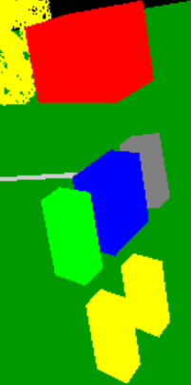

2- The erdtree:

The erdtree is huge tree in the lands between, it is give the grace to all people in the lands between(the land between is the name of the elden ring)

I used recursion to draw the tree and its twigs

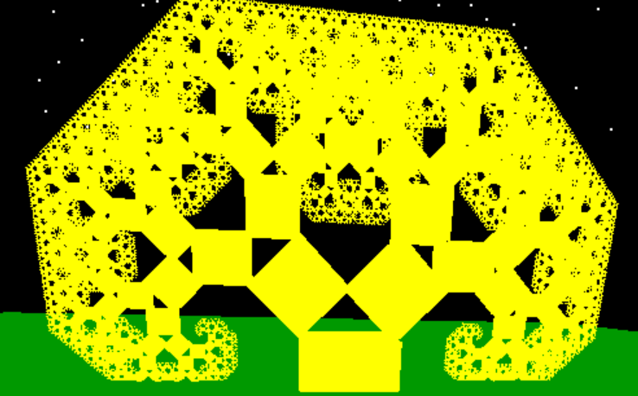

3- the sky that contains stars:

I draw the sky with full of points as stars and make it move.

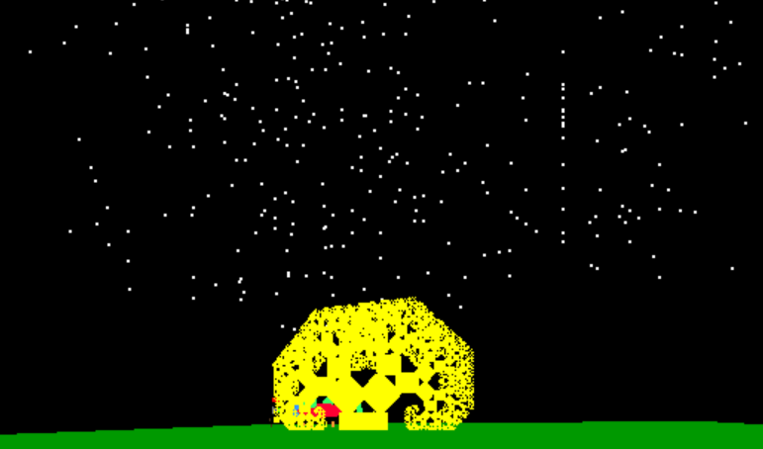

The code :

// Seed the random number generator

srand(time(NULL));

// Draw a large number of stars

glBegin(GL_POINTS);

for (int i = 0; i < 1000; ++i) {

// Randomly position stars within the viewing frustum

float x = static_cast<float>(rand() % 20 - 10);

float y = static_cast<float>(rand() % 20 + 5); // Ensure stars are above the horizon

float z = static_cast<float>(rand() % 20 - 10);

glVertex3f(x, y, z);

}

glEnd();

4 – the dragon:

I draw the dragon using a mix of sphere and cone

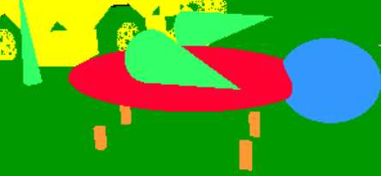

5- the sowrd:

I draw the sword using cylinder and it contains 4 parts.

The blade, the guard, the handle, and the pommel

The code :

void DrawSword() {

// Draw the blade (a long, thin cube)

glPushMatrix();

glColor3f(0.8f, 0.8f, 0.8f); // Silver color for the blade

glTranslatef(0.0f, 0.0f, -2.0f); // Position the blade

glScalef(0.1f, 0.02f, 2.0f); // Scale the cube to form a blade

DrawCube(1.0f);

glPopMatrix();

// Draw the guard (a short, wide cube)

glPushMatrix();

glColor3f(0.5f, 0.5f, 0.5f); // Grey color for the guard

glTranslatef(0.0f, 0.0f, -1.0f); // Position the guard

glScalef(0.4f, 0.05f, 0.1f); // Scale the cube to form the guard

DrawCube(1.0f);

glPopMatrix();

// Draw the handle (a long, thin cylinder)

glPushMatrix();

glColor3f(0.3f, 0.2f, 0.1f); // Brown color for the handle

glTranslatef(0.0f, 0.0f, 1.0f); // Position the handle

glRotatef(90.0f, 1.0f, 0.0f, 0.0f); // Rotate to align with the blade

DrawCylinder(0.05f, 0.05f, 1.0f);

glPopMatrix();

// Draw the pommel (a small cube)

glPushMatrix();

glColor3f(0.5f, 0.5f, 0.5f); // Grey color for the pommel

glTranslatef(0.0f, 0.0f, 1.9f); // Position the pommel at the end of the handle

glScalef(0.1f, 0.1f, 0.1f); // Scale the cube to form the pommel

DrawCube(1.0f);

glPopMatrix();

}

Animation:

I make the swinging move with the sword up and down in the right hand by this chunck of code, I will show the equation:

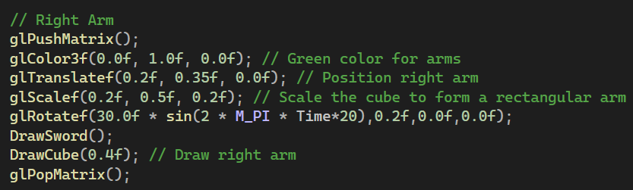

Camera Positions:

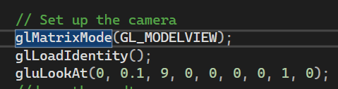

The camera position is fixed and it shows how the player is fight with the dragon with his sword.

End of the project